
S. G. BALEKUNDRI INSTITUTE OF TECHNOLOGY
Shivabasavanagar, Belagavi - 590 010, Karnataka, India
An ISO 21001:2018 Certified Institution | Approved by AICTE, New Delhi | Affiliated to VTU, Belagavi
Department of Computer Science and Business Systems
A Mini Project Report on
“Hybrid Cryptographic Encryption System Using RSA and AES”
A Secure Electronic Health Record (EHR) Vault
Submitted in partial fulfillment of the requirements for the award of the degree of
Bachelor of Engineering
in
Computer Science and Business Systems
Submitted by
[ Student Name ] [ USN ]
Under the guidance of
[ Guide Name ], [ Designation ]
Academic Year 20__ - 20__

CERTIFICATE
This is to certify that the mini project entitled “Hybrid Cryptographic Encryption System Using RSA and AES - A Secure Electronic Health Record (EHR) Vault” is a bonafide work carried out by [ Student Name ] ([ USN ]) in partial fulfillment of the requirements for the award of the degree of Bachelor of Engineering in Computer Science and Business Systems of Visvesvaraya Technological University, Belagavi, during the academic year 20__ - 20__. It is certified that all corrections / suggestions indicated during the internal evaluation have been incorporated in the report. The mini project report has been approved as it satisfies the academic requirements in respect of the mini project work prescribed for the said degree.

Signature of the Guide | Signature of the Coordinator | Signature of the HOD

ABSTRACT
Electronic Health Records contain highly sensitive personal data that must remain confidential and tamper-proof. This project implements a Secure EHR Vault built on a hybrid cryptosystem that combines symmetric and asymmetric encryption. Each uploaded report is encrypted with a fresh AES-256-GCM key; that key is wrapped using the owner's RSA-3072 public key, so only the owner's passphrase-protected private key can recover it. A SHA-256 fingerprint and the AES-GCM authentication tag detect any tampering. The private key is secured with an Argon2id key derived from a dedicated passphrase that is never stored, making the server zero-knowledge. The system is delivered as a Streamlit web application with optional cloud storage over HTTPS.

TABLE OF CONTENTS
Sl. No. | Content | Page No.
 | Abstract
1 | Introduction
 | 1.1 Overview
 | 1.2 Aim and Objectives
 | 1.3 Literature Survey
2 | Existing System
3 | Proposed System
 | 3.1 System Architecture
 | 3.2 Module Description
 | 3.3 Hybrid Encryption Scheme
4 | System Requirements Specification
5 | Implementation
6 | Applications
7 | Conclusion and Future Scope
8 | Bibliography

LIST OF FIGURES
Fig. No. | Figure Name | Page No.
3.1 | System Architecture of the Secure EHR Vault
3.2 | Hybrid RSA + AES Encryption and Decryption Data Flow
5.1 | Account Registration / Login
5.2 | Upload and Encrypt a Document
5.3 | Encrypted-at-rest (ciphertext) View
5.4 | Decrypted View with Integrity Verified
5.5 | Tamper Detection
5.6 | Command-line Demonstration Output

CHAPTER 1
INTRODUCTION
1.1 Overview
Healthcare is rapidly moving from paper files to digital Electronic Health Records (EHRs). While digitisation improves access and continuity of care, it also concentrates sensitive data - diagnoses, lab reports, prescriptions - in systems that can be breached, copied, or silently altered. Regulations and patient trust both demand that such records stay confidential and that any modification be detectable.
A common but weak approach is to store documents in a database or file server and rely on access control or on encryption whose keys are held by the service provider. In such designs, the provider (or anyone who compromises it) can read every record. This project takes a stronger, cryptographically enforced approach: documents are encrypted on the server before storage, but in a way that only the owning user - holding a secret passphrase - can ever decrypt, so even the operator cannot read them.
The solution uses a hybrid cryptosystem. Symmetric encryption (AES-256-GCM) provides fast, authenticated encryption of the file contents, while asymmetric encryption (RSA-3072 with OAEP padding) is used to protect (wrap) the symmetric key so that only the intended user can unlock it. This mirrors the design of widely used secure protocols such as TLS and PGP. Integrity is guaranteed by the AES-GCM authentication tag and an additional SHA-256 fingerprint of the original file.
1.2 Aim and Objectives
Aim: To design and implement a secure EHR storage system in which health-report documents are automatically encrypted using a hybrid of RSA and AES, are accessible only to their owner, and are protected against tampering.
- Confidentiality: Encrypt every uploaded document with a unique AES-256-GCM key.
- Access control: Wrap the AES key with the user's RSA public key so only the owner can decrypt.
- Key management: Protect the RSA private key with an Argon2id key derived from a dedicated, never-stored passphrase (zero-knowledge server).
- Integrity: Detect any modification using the AES-GCM tag and a stored SHA-256 hash.
- Usability & transport: Provide a professional web interface to upload, view, verify and delete records, and transmit data over HTTPS/TLS.
1.3 Literature Survey
[1] W. Diffie and M. Hellman, “New Directions in Cryptography” (1976), introduced public-key cryptography and the idea of using separate keys for encryption and decryption. This project applies that principle through RSA key pairs so that encryption (with a public key) and decryption (with a private key) are cleanly separated per user.
[2] R. Rivest, A. Shamir and L. Adleman, “A Method for Obtaining Digital Signatures and Public-Key Cryptosystems” (1978), defined the RSA algorithm. We use RSA-3072 with OAEP padding to securely wrap the per-file AES key, which is RSA's ideal role (secure transport of a small secret) rather than bulk encryption.
[3] M. Dworkin, NIST SP 800-38D, “Recommendation for Block Cipher Modes of Operation: Galois/Counter Mode (GCM)” (2007), specifies authenticated encryption with AES. We adopt AES-256-GCM so that confidentiality and integrity are provided together, removing the need for a separate message authentication code.
[4] A. Biryukov, D. Dinu and D. Khovratovich, “Argon2: New Generation of Memory-Hard Functions for Password Hashing” (2016), presents the Argon2 KDF. We use Argon2id to turn the user's passphrase into the key that protects their RSA private key, resisting brute-force and GPU attacks far better than a simple hash.

CHAPTER 2
EXISTING SYSTEM
In many existing health-record systems, documents are stored either in plaintext or with server-side encryption where the service provider holds and manages the keys. Access is typically guarded by a single account login shared with the rest of the application.
2.1 Limitations of the Existing System
- The provider (or an attacker who compromises the server/database) can read every stored record, because the decryption keys live on the server.
- A single application login protects the records; if those credentials leak, the documents are exposed.
- Plaintext or provider-encrypted storage offers no cryptographic guarantee that a stored file has not been silently modified.
- There is usually no per-document key, so compromise of one key can expose many or all files.
- Confidentiality depends on trusting the operator rather than on mathematics.

CHAPTER 3
PROPOSED SYSTEM
The proposed Secure EHR Vault encrypts every document on the server before storage using a hybrid scheme, and arranges keys so that only the owning user can decrypt. The design is zero-knowledge: the passphrase that ultimately unlocks a user's data is never stored, so the operator cannot read user documents even if they wanted to.
3.1 System Architecture
The system is organised into three clearly separated layers - a Streamlit presentation layer, a standalone cryptographic engine, and a pluggable storage layer - as shown in Figure 3.1.
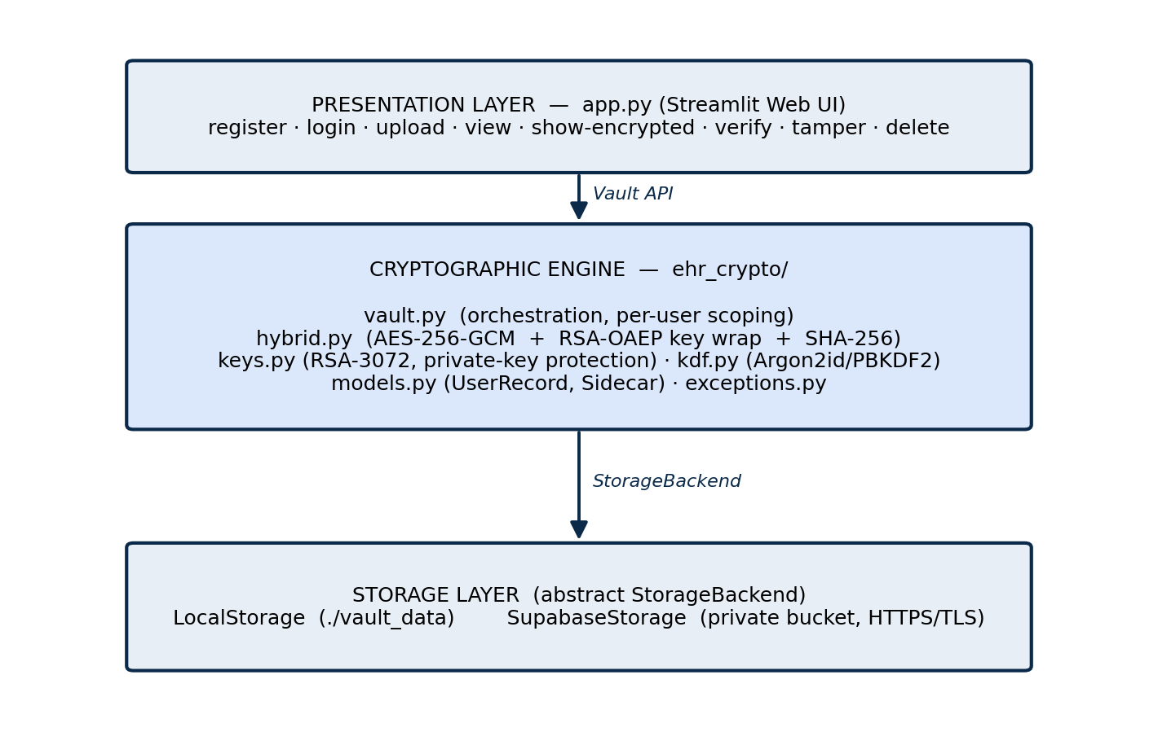
Figure 3.1: System Architecture of the Secure EHR Vault
3.2 Module Description
- app.py: The Streamlit web interface. It handles registration, login, upload, viewing, the encrypted-at-rest view, integrity verification, the tamper demo and deletion. It never performs cryptography itself - it calls the vault engine.
- vault.py: The high-level orchestrator. It implements register, login, upload, list, view and delete, and scopes every object to its owning user.
- hybrid.py: The hybrid encryption core: encrypt_document and decrypt_document, implementing AES-256-GCM encryption, RSA-OAEP key wrapping and SHA-256 integrity.
- keys.py: RSA-3072 key-pair generation and protection of the private key using a passphrase-derived key.
- kdf.py: Key derivation from the passphrase using Argon2id (default) or PBKDF2.
- models.py: The UserRecord and Sidecar data records that are persisted as JSON.
- storage.py: Storage abstraction with a local-disk backend and a Supabase cloud backend.
3.3 Hybrid Encryption Scheme
Figure 3.2 shows the end-to-end data flow. On upload, the file is encrypted with a random AES key which is then wrapped with the user's RSA public key; on view, the private key unwraps the AES key, the file is decrypted, and integrity is verified.
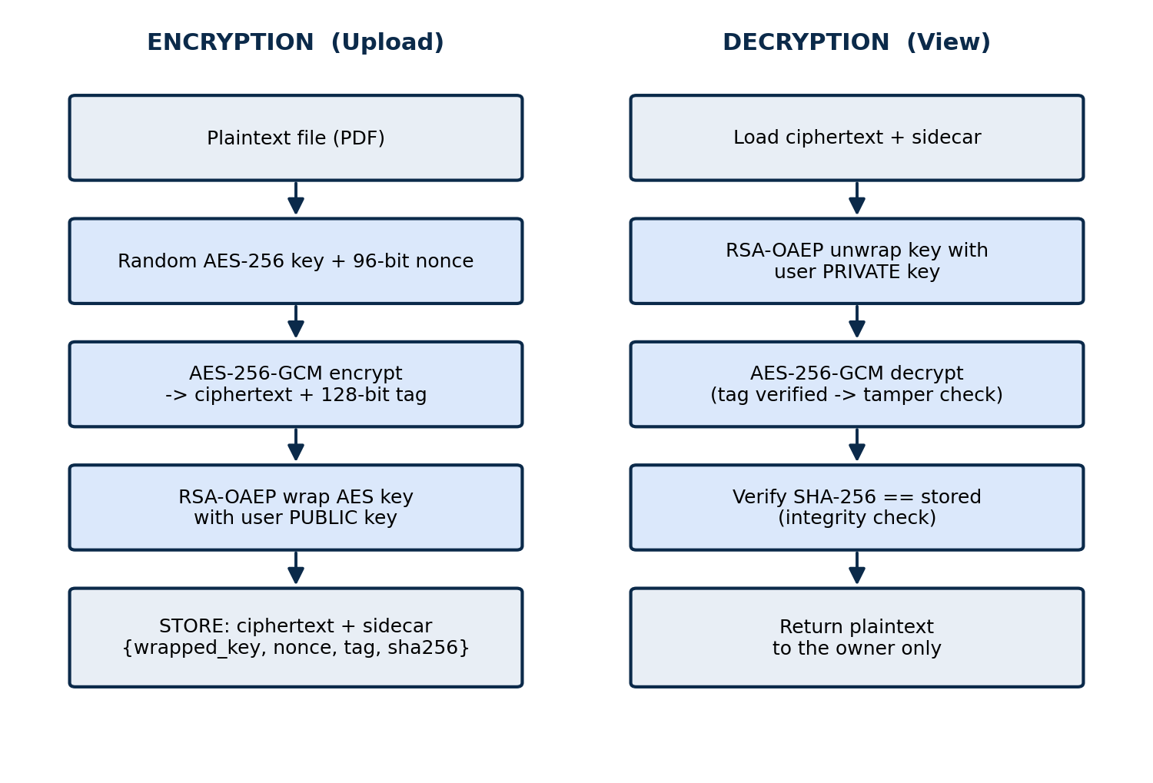
Figure 3.2: Hybrid RSA + AES Encryption and Decryption Data Flow
Only the ciphertext and a small metadata record (the wrapped AES key, the nonce, the authentication tag and the SHA-256 fingerprint) are stored. The plaintext file and the raw AES key are never written to storage.

CHAPTER 4
SYSTEM REQUIREMENTS SPECIFICATION
4.1 Hardware Requirements
- Processor: Dual-core 2.0 GHz or higher (x86-64).
- RAM: 4 GB minimum (8 GB recommended; Argon2id uses 64 MiB per derivation).
- Storage: 500 MB free for the environment and encrypted vault.
- A standard laptop/desktop; internet connection required only for the optional cloud (Supabase) backend and for deployment.
4.2 Software Requirements
- Operating System: Windows 10/11, Linux or macOS.
- Python 3.10 or newer (developed and tested on Python 3.13).
- Libraries: streamlit, cryptography, argon2-cffi, supabase (optional), pytest.
- A modern web browser (Chrome, Edge, Firefox).
- Optional: a Supabase account with a private Storage bucket for cloud persistence.

CHAPTER 5
IMPLEMENTATION
The cryptographic engine is implemented in pure Python using the cryptography and argon2-cffi libraries; no cryptographic primitive is hand-written. The engine exposes a Vault class used by a Streamlit application. The following screenshots show the working system. (Each screenshot is preceded by a two-line explanation, as required.)
5.1 Registration and Login
The user creates an account with a username and a dedicated EHR passphrase; this generates an RSA-3072 key pair whose private key is encrypted with an Argon2id-derived key.
On login, the passphrase re-derives that key and decrypts the private key into memory for the session only; a wrong passphrase fails the authentication-tag check and is rejected.
[ Paste screenshot here: Account Registration / Login ]
Figure 5.1: Account Registration / Login
5.2 Uploading and Encrypting a Document
The user selects a PDF health report and clicks Encrypt & store; a fresh AES-256-GCM key encrypts the file and is then wrapped with the user's RSA public key.
The interface confirms storage and shows a preview of the raw encrypted bytes, proving the stored content is unreadable ciphertext.
[ Paste screenshot here: Upload and Encrypt a Document ]
Figure 5.2: Upload and Encrypt a Document
5.3 Encrypted-at-rest View
The Show-encrypted option displays exactly what is written to storage: a hex dump of the ciphertext together with the sidecar metadata (wrapped key, nonce, tag, SHA-256).
The bytes do not begin with %PDF and contain no readable text, demonstrating that an attacker with storage access cannot read the document.
[ Paste screenshot here: Encrypted-at-rest (ciphertext) View ]
Figure 5.3: Encrypted-at-rest (ciphertext) View
5.4 Viewing (Decryption) with Integrity Check
When the owner clicks View, the private key unwraps the AES key, the file is decrypted and its SHA-256 is re-verified against the stored value.
An Integrity verified badge is shown and the original PDF is rendered and made available for download, confirming a correct round-trip.
[ Paste screenshot here: Decrypted View with Integrity Verified ]
Figure 5.4: Decrypted View with Integrity Verified
5.5 Tamper Detection
The Tamper demo corrupts a single byte of the stored ciphertext to simulate an attack on the storage medium.
The next View attempt fails the AES-GCM authentication check and the system clearly reports an integrity failure instead of returning corrupted data.
[ Paste screenshot here: Tamper Detection ]
Figure 5.5: Tamper Detection
5.6 Command-line Demonstration and Testing
A standalone console demo (demo.py) registers two users, encrypts a report, shows the unreadable ciphertext, decrypts it back, and proves another user cannot decrypt it.
An automated test suite (pytest) verifies the encrypt-decrypt round trip, wrong-user rejection and tamper detection - all eight tests pass.
[ Paste screenshot here: Command-line Demonstration Output ]
Figure 5.6: Command-line Demonstration Output

CHAPTER 6
APPLICATIONS
- Secure storage of patient health records, lab reports and prescriptions in hospitals and clinics.
- Personal medical document vaults where individuals keep their own reports private.
- Telemedicine platforms that must store and exchange confidential documents.
- Insurance and legal document archives requiring confidentiality and tamper evidence.
- Any application needing per-user, zero-knowledge encrypted file storage with integrity guarantees.

CHAPTER 7
CONCLUSION AND FUTURE SCOPE
7.1 Conclusion
The project successfully implements a Secure EHR Vault using a hybrid RSA and AES cryptosystem. Documents are automatically encrypted with per-file AES-256-GCM keys that are wrapped using each user's RSA-3072 public key, ensuring that only the owner can decrypt them. The owner's private key is protected by an Argon2id key derived from a passphrase that is never stored, so the server remains zero-knowledge. The AES-GCM authentication tag together with a stored SHA-256 fingerprint guarantees that any tampering is detected. Delivered as a Streamlit web application with HTTPS transport and an optional cloud backend, the system meets its goals of confidentiality, per-user access control and integrity.
7.2 Future Scope
- Encrypt document metadata (filename, size, dates) in addition to contents.
- Add secure sharing by re-wrapping a file's AES key with a doctor's public key.
- Introduce multi-factor authentication and an optional key-recovery/escrow scheme.
- Maintain a tamper-evident audit log of all access and modification events.
- Provide a mobile client and integrate with hospital information systems.

CHAPTER 8
BIBLIOGRAPHY
[1] W. Diffie and M. E. Hellman, “New Directions in Cryptography,” IEEE Transactions on Information Theory, vol. 22, no. 6, pp. 644-654, 1976.
[2] R. L. Rivest, A. Shamir and L. Adleman, “A Method for Obtaining Digital Signatures and Public-Key Cryptosystems,” Communications of the ACM, vol. 21, no. 2, pp. 120-126, 1978.
[3] M. Dworkin, “Recommendation for Block Cipher Modes of Operation: Galois/Counter Mode (GCM) and GMAC,” NIST Special Publication 800-38D, 2007.
[4] A. Biryukov, D. Dinu and D. Khovratovich, “Argon2: New Generation of Memory-Hard Functions for Password Hashing,” IEEE European Symposium on Security and Privacy, 2016.
[5] National Institute of Standards and Technology, “Advanced Encryption Standard (AES),” FIPS Publication 197, 2001.
[6] K. Moriarty, B. Kaliski, J. Jonsson and A. Rusch, “PKCS #1: RSA Cryptography Specifications Version 2.2,” RFC 8017, 2016.
[7] Python Cryptographic Authority, “cryptography library documentation,” cryptography.io.
[8] Streamlit Inc., “Streamlit documentation,” streamlit.io.

